f1 = xlsread('20hz.xlsx'); f2 = xlsread('50hz.xlsx'); f3 = xlsread('75.xlsx'); f4 = xlsread('100hz.xlsx');
f5 = xlsread('200hz.xlsx'); f6 = xlsread('500hz.xlsx'); f7 = xlsread('2000hz.xlsx');
f8 = xlsread('3000hz.xlsx'); f9 = xlsread('3500hz.xlsx'); f10 = xlsread('4000hz.xlsx');
data = [ f1(8:end,2), f2(8:end,2), f3(8:end,2), f4(8:end,2), f5(8:end,2), f6(8:end,2), f7(8:end,2), f8(8:end,2), f9(8:end,2), f10(8:end,2)];
Fs = 5000; % Sampling frequency(The number of times the SIGNAL is SENT per second)
T = 1/Fs; % Sampling period
L = 1000; % Length of signal
measurement_time = T*L; % measurement_time
Y = fft(data);
ampY = abs(Y(1:L/2,:));
f_axis = 1/measurement_time*(1:L/2);
[amp,index] = max(ampY);
f =[];
for i=1:10
f(i) = f_axis(index(i));
end
distance = [20,50,75,100,200,500,2000,3000,3500,4000];
plot(distance,f,'.','MarkerSize',10)
hold on
plot(0:0.1:2500,0:0.1:2500,'--','color','red','LineWidth',0.5 )
xlable = 'Frequencies sent (hz)';
ylable = 'Frequencies measured (hz)';
xlabel(xlable,'FontSize',16)
ylabel(ylable,'FontSize',16)
title('The frequencies measured as a function of the frequencies sent')
legend('Frequencies', 'Linear fit: y = x','Location','northwest')
xlim([0,4500])
grid on
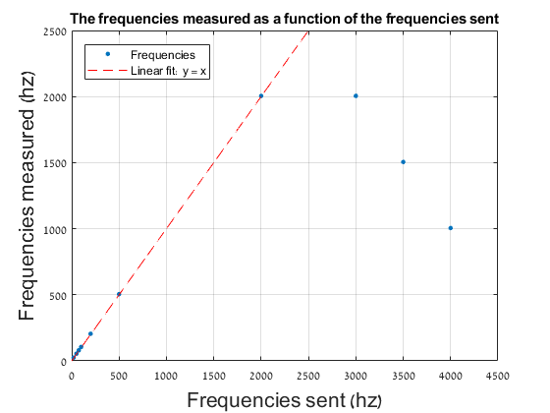
Published with MATLAB® R2017b

